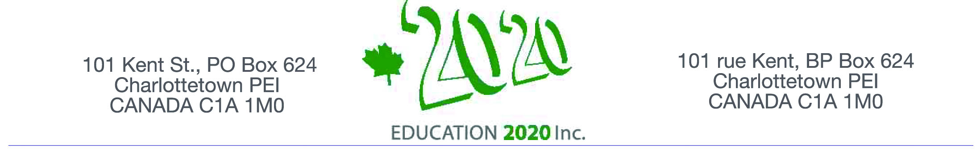

On behalf of Education 20/20 Inc.
I am pleased to invite you to a presentation by
Dr. Tammy Hubley-Little.
Leader of Curriculum Delivery for the English Language School Board
on the topic of

“Education”

The event is informal and will provide opportunities to meet and talk
to others who share an interest in education.
The session, the first of a series of conversations with Island educators,
will be held at the

Haviland Club from 4-6:00 pm
Wednesday, January 21, 2015

Dr. Hubley-Little has taught pre-school, secondary and post secondary education in the private and public sectors in England, Norway and Canada;
she holds a Master's degree in Counseling, Master of Arts in Education,
and a Doctorate from Durham University in England.

I look forward to seeing you on January 14.
Don Glendenning, President

Space is limited so an early RSVP is requested
Email: pei@education2020.ca

Education 20/20 inc. is an independent, broad based, national, not-for-profit education organization located in Charlottetown; its mission is to support a quality education for every Canadian.

